**Software Requirements Specification (SRS)**

**For Mid D1ay Meal**

**Table of Contents**

**Table of Contents .......................................................................................................... 2**

**1. Introduction .............................................................................................................. 3**

1.1 Purpose................................................................................................................................3

1.2 Document Conventions ........................................................................................................3

1.3 Intended Audience and Reading Suggestions.......................................................................3

**2. Overall Description .................................................................................................. 3**

2.1 Product Perspective ............................................................................................................... 3

2.2 User Classes and Characteristics ........................................................................................... 4

2.3 Operating Environment ...........................................................................................................4

2.4 Assumptions and Dependencies ............................................................................................ 4

**3. External Interface Requirements .......................................................................... 4**

3.1 User Interfaces ..................................................................................................................... 4

3.2 Communications Interfaces .................................................................................................. 4

3.3 Use case Diagram…………………………………………………………………………….5

**4. System Features .................................................................................................... 6**

4.1 Actors............................................................................................................... 6

4.2 Functoinilities........................................................................................................................ 6

**5. Other Nonfunctional Requirements ..................................................................... 6**

5.1 Performance Requirements ..................................................................................................6

5.2 Safety Requirements ............................................................................................................ 6

5.3 Security Requirements ......................................................................................................... 6

5.4 Software Quality Attributes ...................................................................................................7

**6. References………………………………………………………………………………7**

# Introduction

* 1. **Purpose**

The purpose of this document is to present a detailed description of the open-source software Mid day meal. It will explain the purpose and features of the software, the interfaces of the software, what the software will do and the constraints under which it must operate. This document is intended for users of the software and also potential developers.

* 1. **Document Conventions**

This Document was created based on the IEEE template for System Requirement Specification Documents.

* 1. **Intended Audience and Reading Suggestions**
* Potiential users, such as job holders, students, teachers, and specially for bachelors who want to use Mid day meal for ordering their lunches in lunch time through Social networks, like :facebook, email,or providing their contract number.
* Advanced/Professional Users, such as businessman or entrepreneurs, who want to use mid day meal for more demanding business analysis.
* Programmers who are interested in working on the project by further developing it or fix existing bugs.

# 2. The Overall Description

**2.1 Product Perspective**

Mid day meal was developed for everyone who is interested in ordering their lunches in lunch time and wants either to just experiment with the system so that usres can understand the overall system

or wants to use the system as a means for their services. It can handle various services like delivary on office, home, or workplace alongwith various lunche items.

# It is an open source project and it has a very active developer team to support it and provide feedback to users. It was developed to run on Windows, and Linux.

### 

### 2.2 User Classes and Characteristics:

Potiential users, such as job holders, students, teachers, and specially for bachelors who want to use Mid day meal for ordering their lunches in lunch time through Social networks, like :facebook, email,or providing their contract number.

Advanced/Professional Users, such as businessman or entrepreneurs, who want to use mid day meal for more demanding business analysis.

Programmers who are interested in working on the project by further developing it or fix existing bugs.

**2.3 Operating Environment**

• Windows XP

• Windows Vista

• Windows 7

• Windows 8

• Windows 10

• Linux

**2.4 Assumptions and Dependencie**

Mid day meal is dependent on axios, twbs, kentcdodds, jquery, jeffrayWay, lodash, vuejs

1. **External Interface Requirements**
   1. **& 3.2 User Interfaces & Communications Interfaces:**

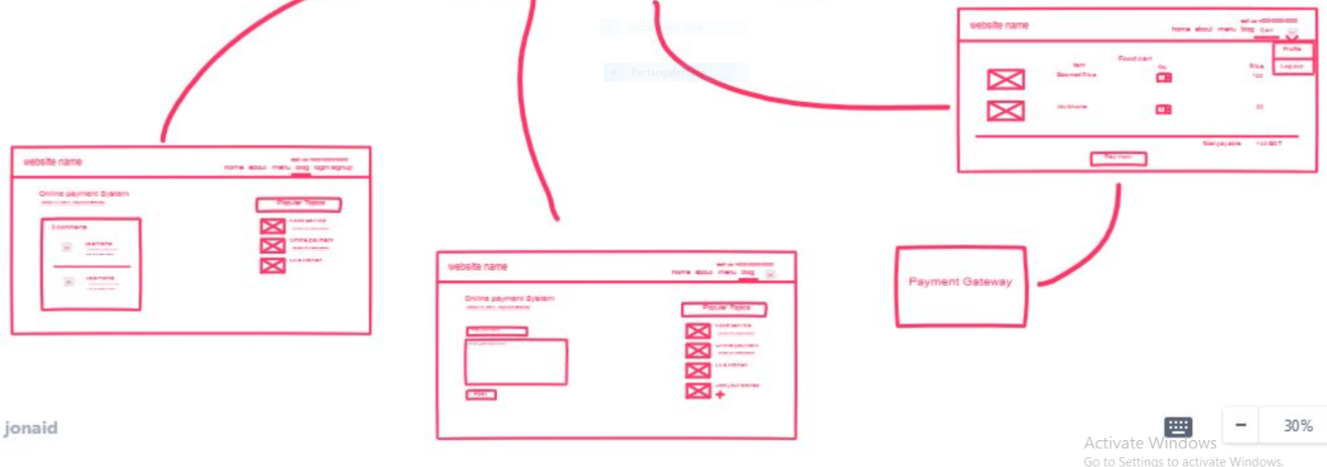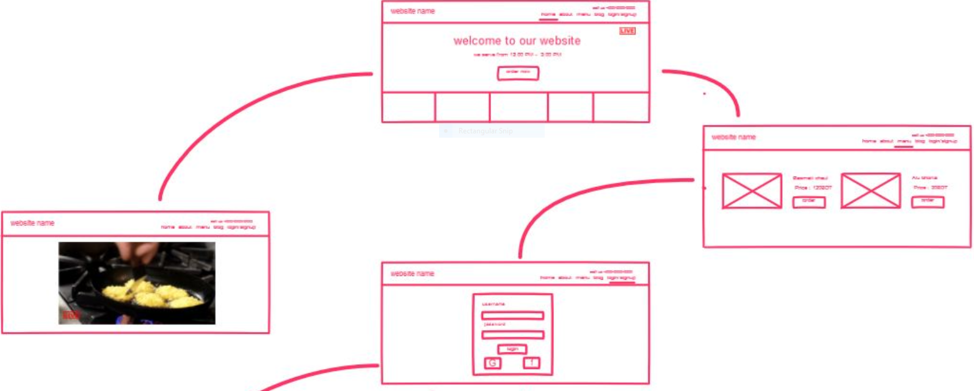

**3.3 Use case Diagram:**

# abirwe

# Specific Requirements

**4.1 Actors**

* Online users (customers)
* software users (admin)
* employee/worker
* cook

**4.2 Functionalities**

* User order food
* User pays for food
* Receives order(admin)
* Sends requirements to manager
* Manager sends requirement to supplier
* Manager sends order to kitchen (cook)
* Supplier sends raw items to kitchen
* Cook starts cooking
* Cooked food is sent to delivery sytem
* Delivery system delivers the food to customer

**5.1 Performance Requirements**

Mid day meal requires a system with at least a 500 megahertz CPU and 128 megabytes of RAM and an OPENGL 1.2 compatible graphics card. However, these requirements can support effectively.

**5.2 Safety Requirements**

To ensure that no one of Mid-day meal’s users loses any data while using Mid DayMeal (due to a crash or a bug of some kind) the developer team updates Mid day meal regularly. There is a bug tracker available where users can report any bugs they have encountered so that the developers can fix it in the next release.

**5.3 Security Requirements**

Mid day meal does not have any security requirements and thus any type of user can use it without any additional privileges.